Problem Statement- This design is meant to help the casual fisherman who are on Lake Oconee and may not know the regulations for keeping fish on the lake, as well as give them a way to accurately record their fishes weight so that they can go home and brag accordingly.

Proposed idea- This design will include a digital scale that when the fish is placed onto it, will display the weight onto the main screen. It will also house a database with fishing regulations and slot limits for fish to be kept regarding Lake Oconee in Georgia.

Influences-

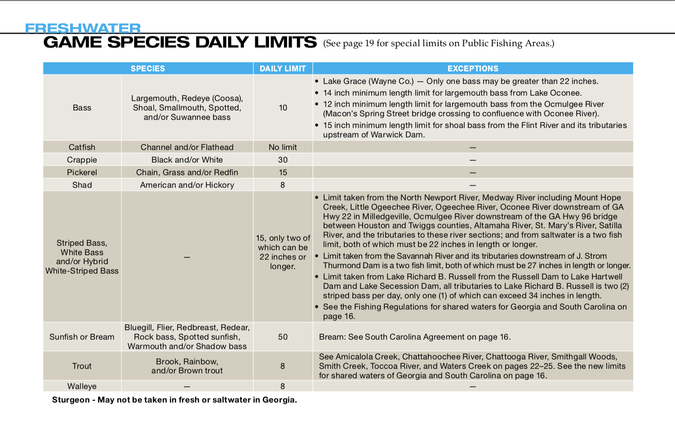

<http://www.eregulations.com/wp-content/uploads/2017/01/17GAFW_LR.pdf> (fishing regulation, limits)

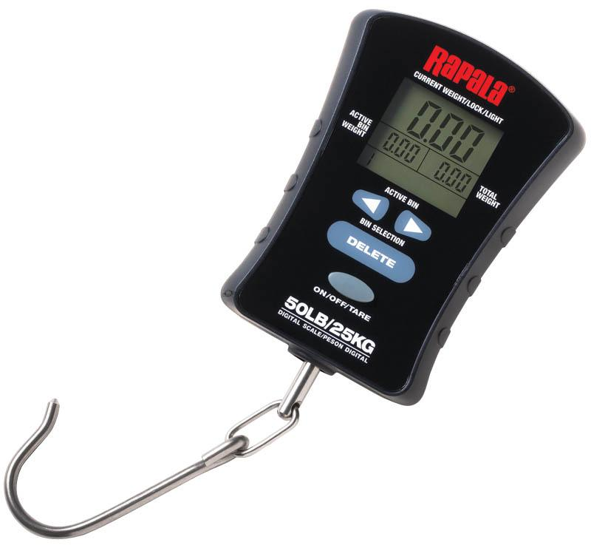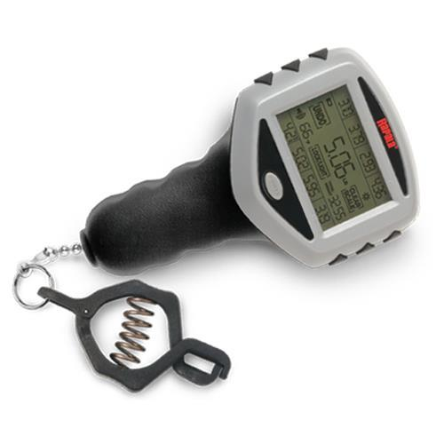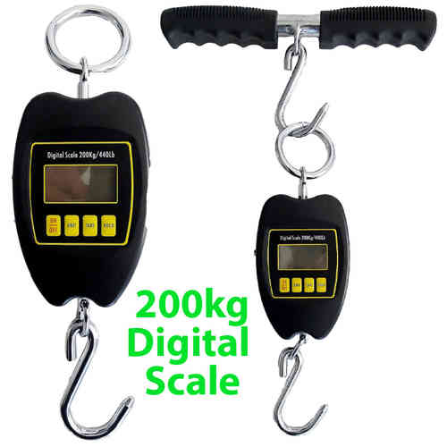 Digital fish scales

<https://www.google.com/search?q=digital+fish+scale&client=safari&rls=en&source=lnms&tbm=isch&sa=X&ved=0ahUKEwj10amM3dzYAhWN11MKHb91ClwQ_AUICygC&biw=1679&bih=886#imgrc=7srkSL1yAru0SM>:

<http://judicial.alabama.gov/library/rules/ja20_appxb.pdf>

This is the legislation as to fines which range from a minimum of $50 to up to $250 for violating fishing regulations.

Types of sensors for digital weight scale

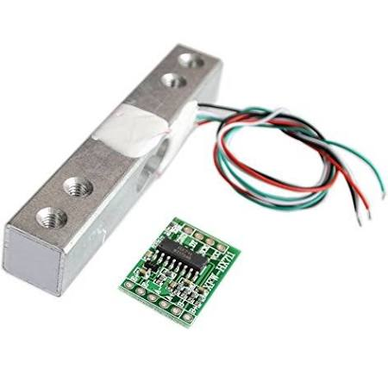

<https://www.amazon.com/dp/B076P8G8B6/ref=asc_df_B076P8G8B65339828/?tag=hyprod-20&creative=395033&creativeASIN=B076P8G8B6&linkCode=df0&hvadid=228860412633&hvpos=1o2&hvnetw=g&hvrand=11261616787935738580&hvpone=&hvptwo=&hvqmt=&hvdev=c&hvdvcmdl=&hvlocint=&hvlocphy=9010853&hvtargid=pla-391309017493>

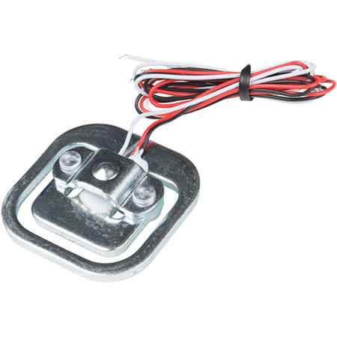

<https://www.robotshop.com/en/sfe-load-sensor-50kg.html?gclid=CjwKCAiAhfzSBRBTEiwAN-ysWGeKlwSPwzup9yJMrJjZgKdc8Meyo37Hy9ofPL6_Io4FpWVcPe7vmBoCO_0QAvD_BwE>